CS Bridge Module 9 Arrays

1. Motivation

1.1 CS Bridge: Introduction to Static Arrays
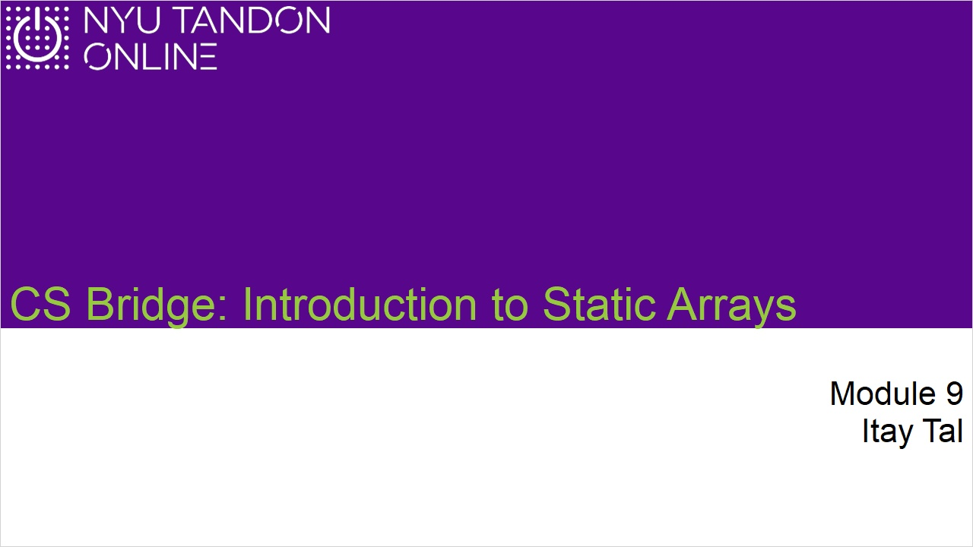
Notes:

1.2 Motivation
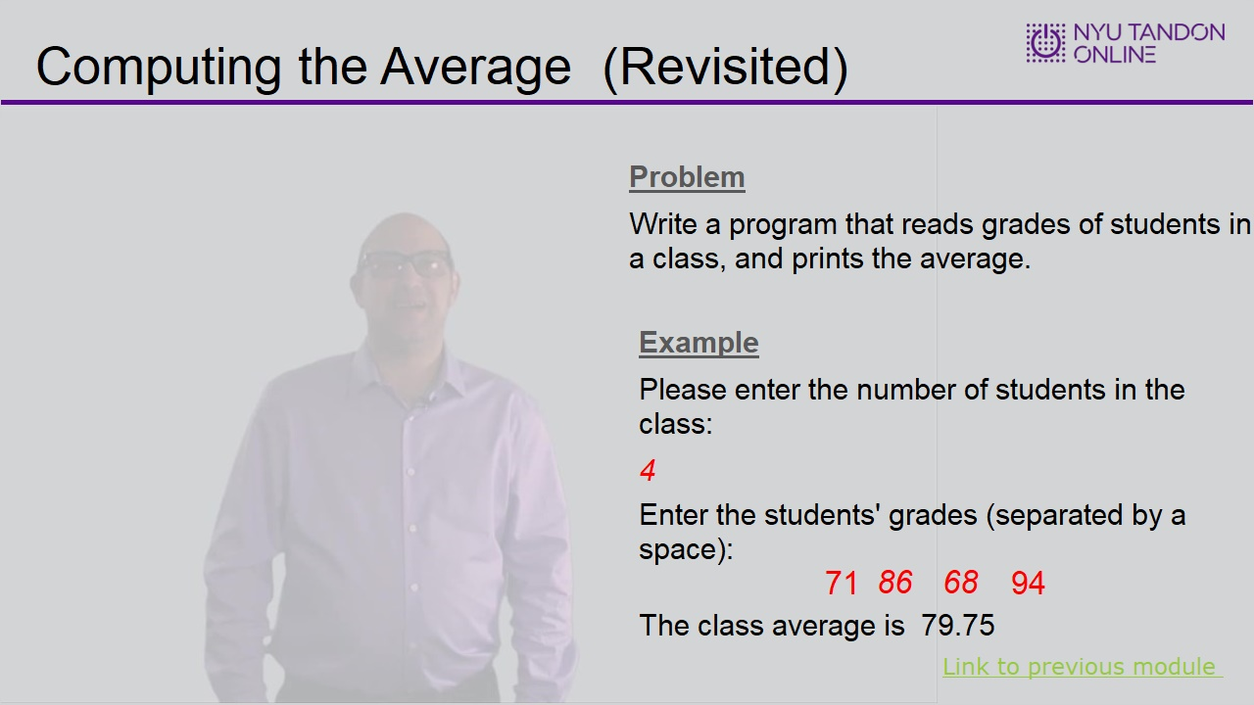

1.3 Calculate Average Implementation
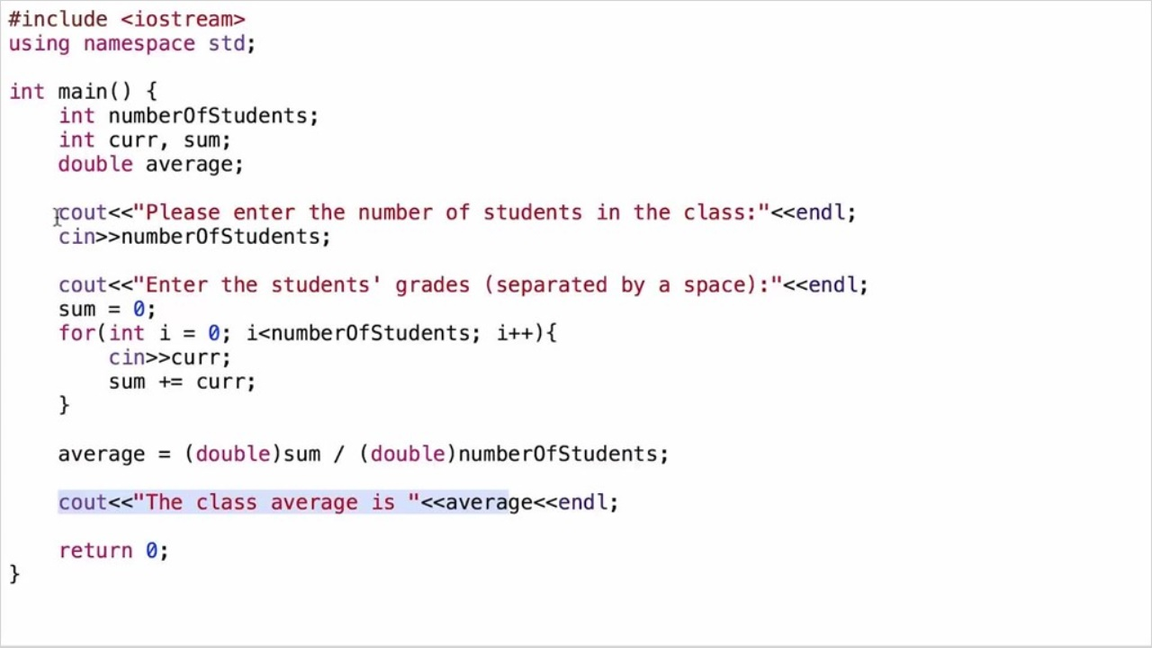

1.4 Above the Average
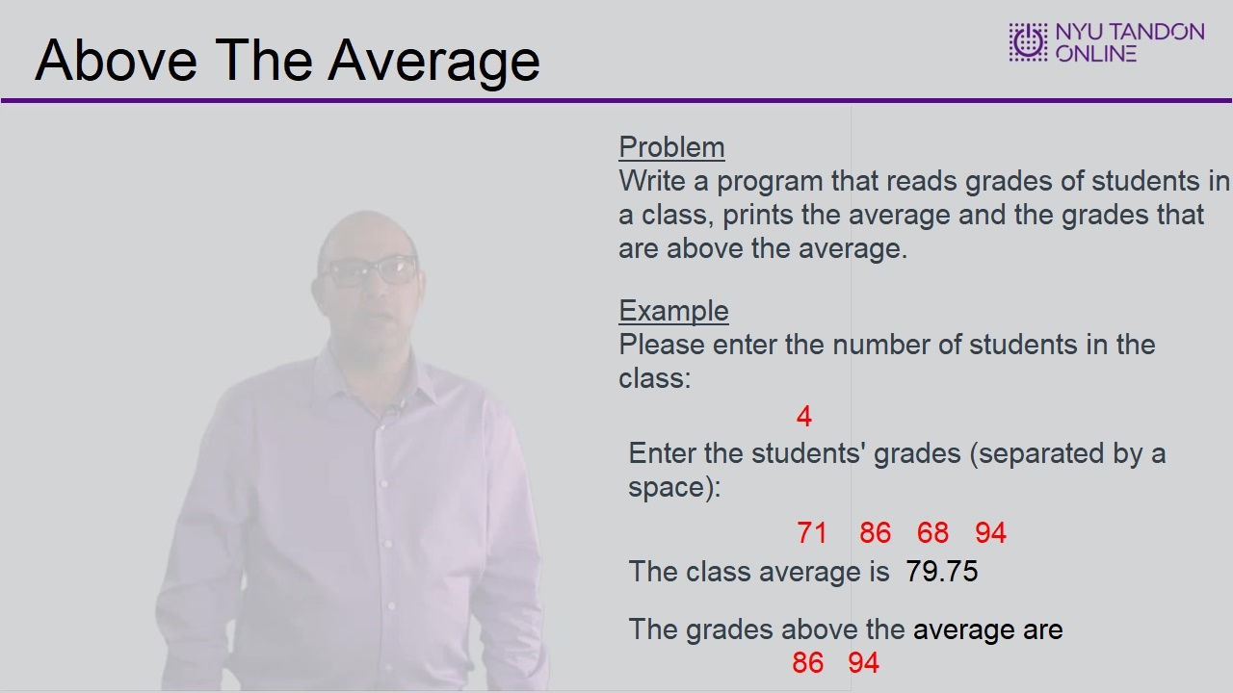

1.5 Implementation
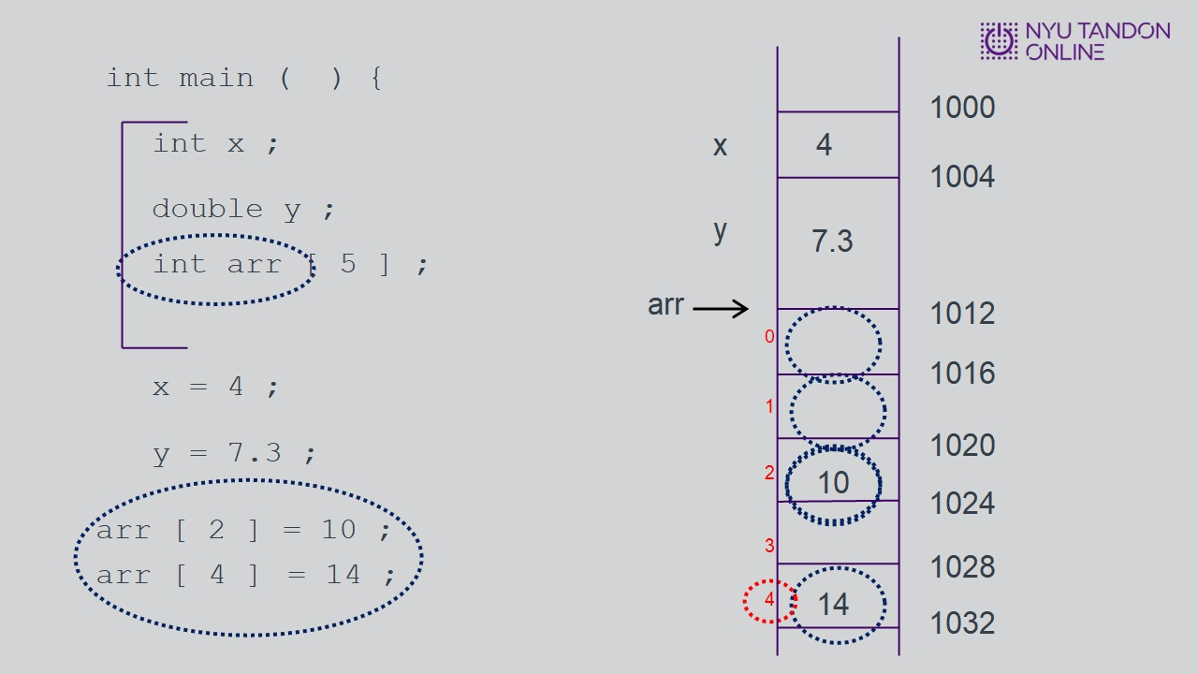
Notes:

2. Array Basics

2.1 Array Basics
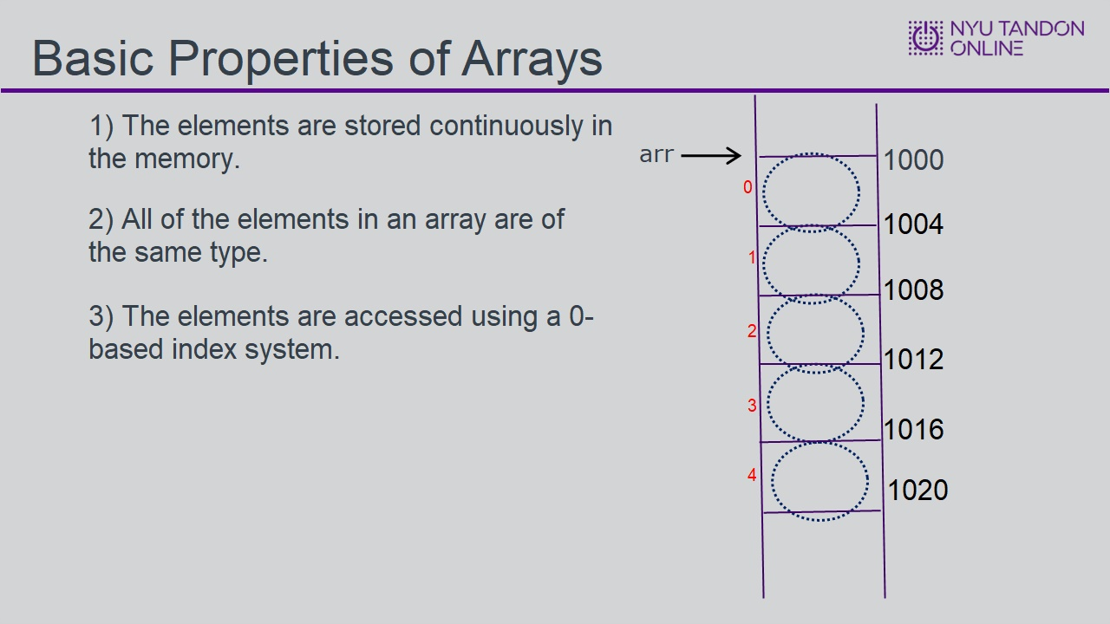
Notes:

2.2 Basic Array Properties
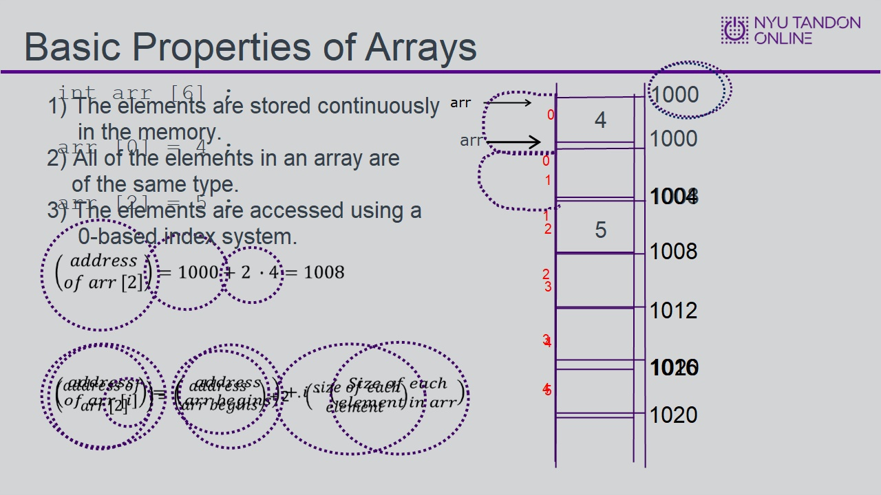

2.3 Basic Array Properties Cont'd
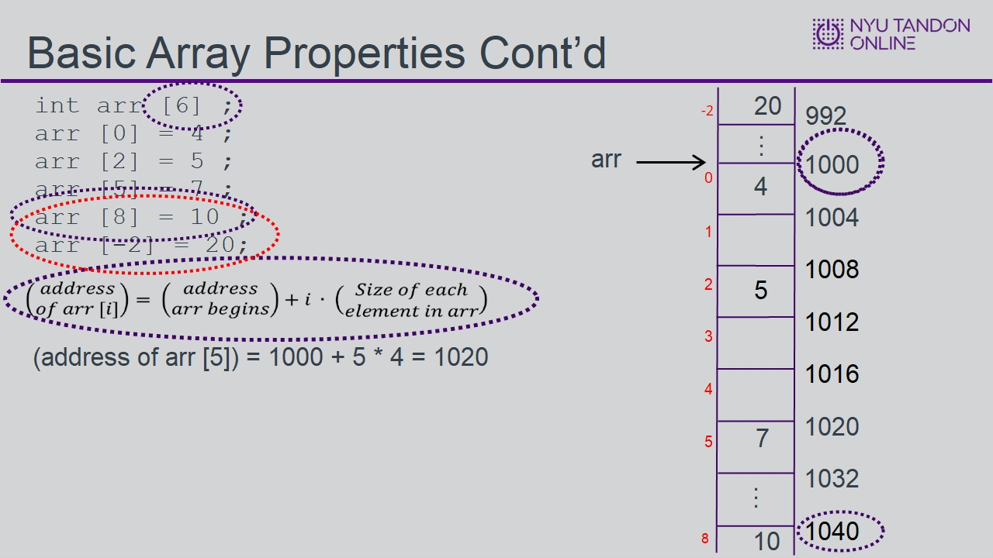

2.4 Syntactic Notes
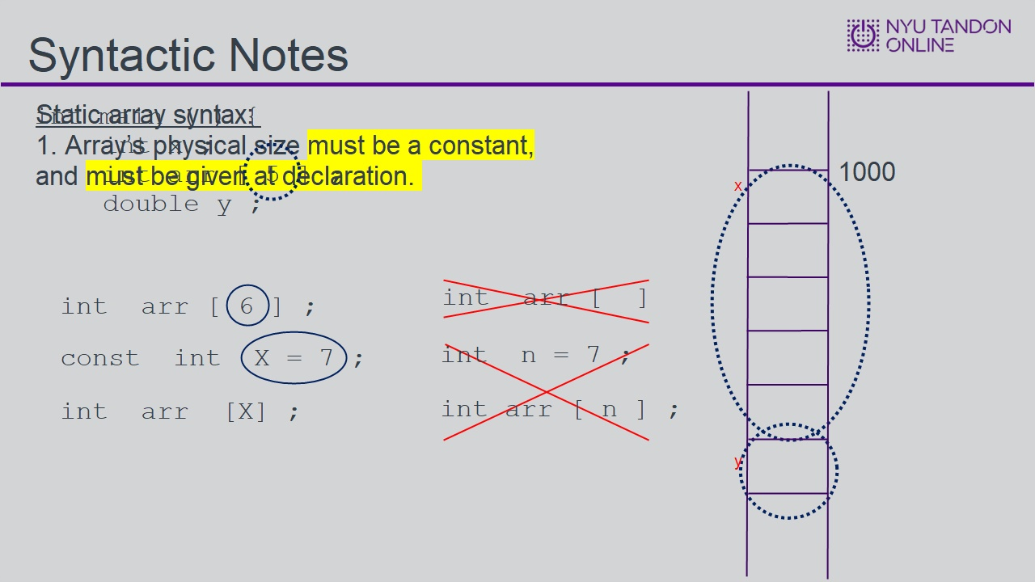

2.5 Knowledge Check
(Multiple Response, 10 points, 6 attempts permitted)
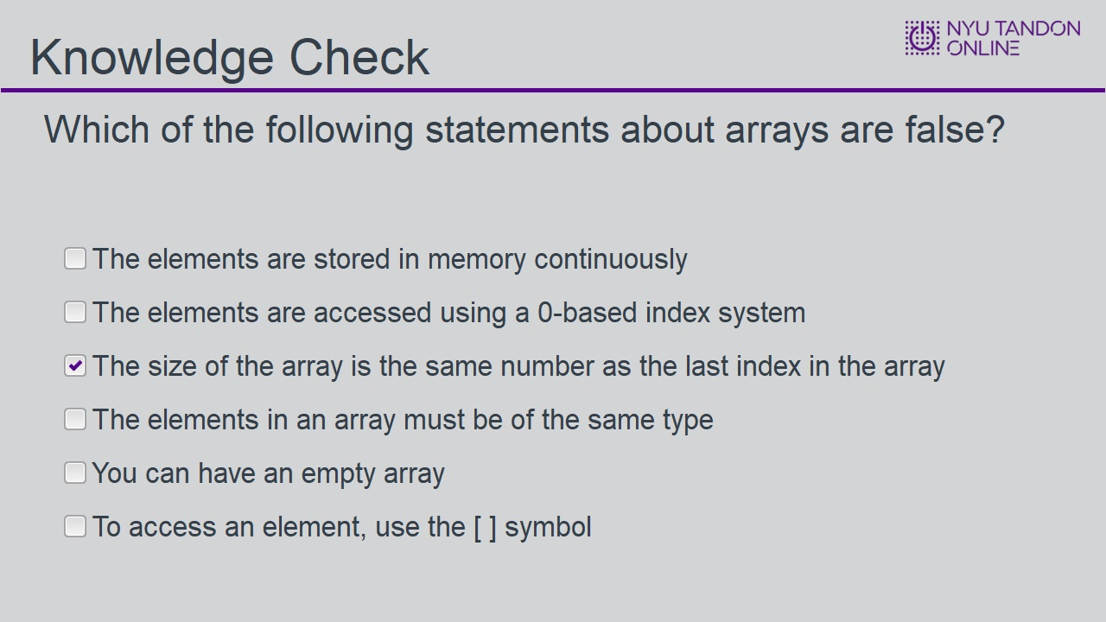
Correct | Choice
 | The elements are stored in memory continuously
 | The elements are accessed using a 0-based index system
X | The size of the array is the same number as the last index in the array
 | The elements in an array must be of the same type
 | You can have an empty array
 | To access an element, use the [ ] symbol
Feedback when correct:
That's right! You selected the correct response.
Feedback when incorrect:
You did not select the correct response.

Correct (Slide Layer)
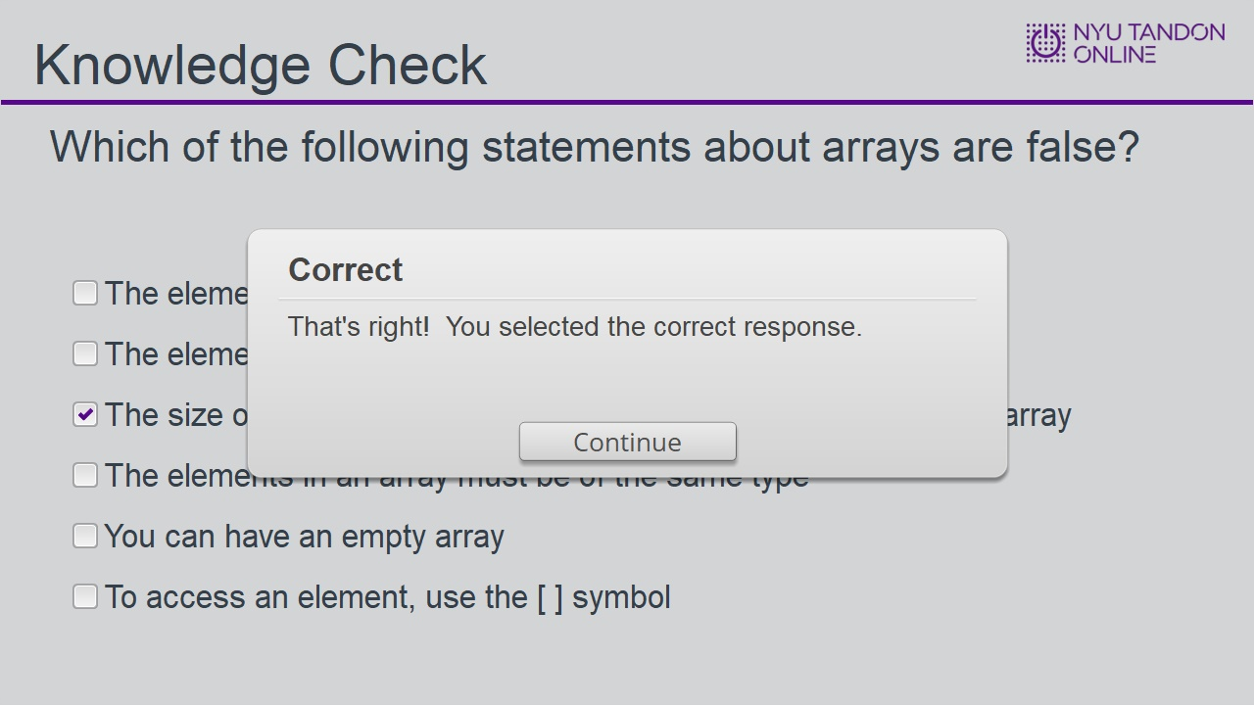

Incorrect (Slide Layer)
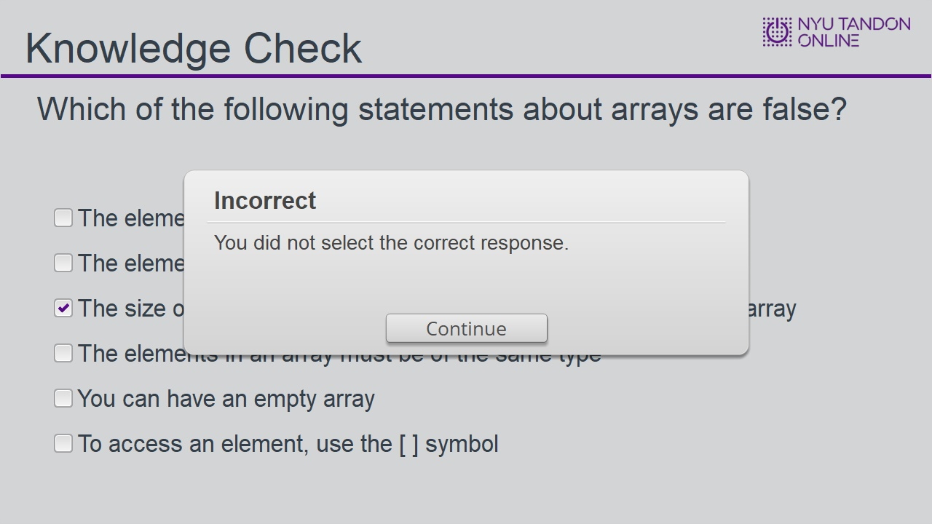

Try Again (Slide Layer)
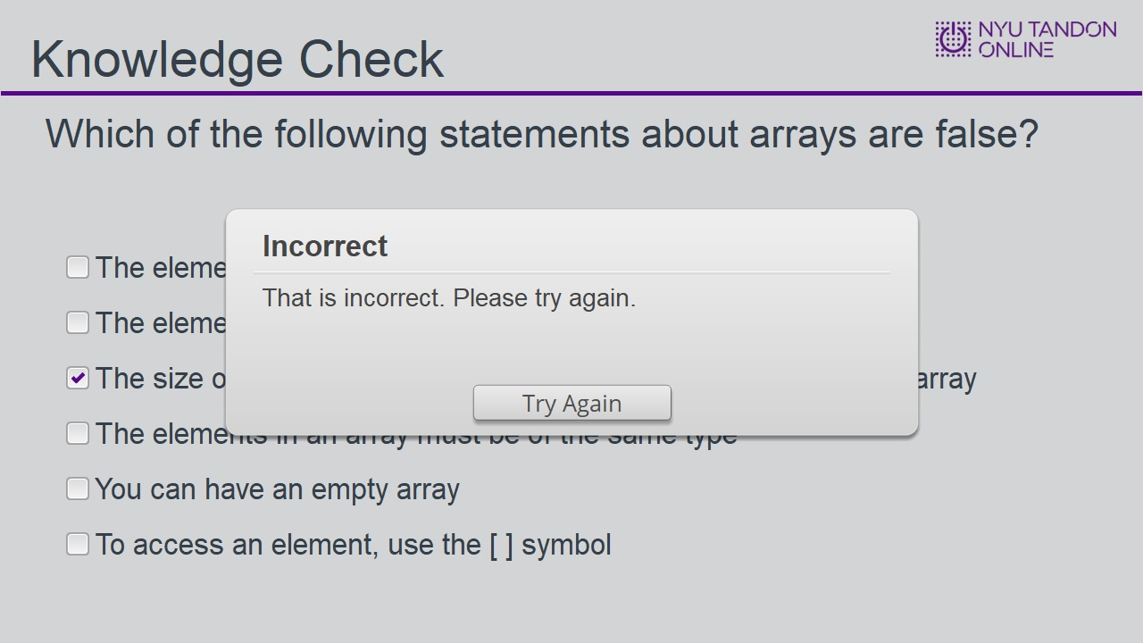

3. Solve the Above Average Problem

3.1 Above The Average


3.2 Above Average 1
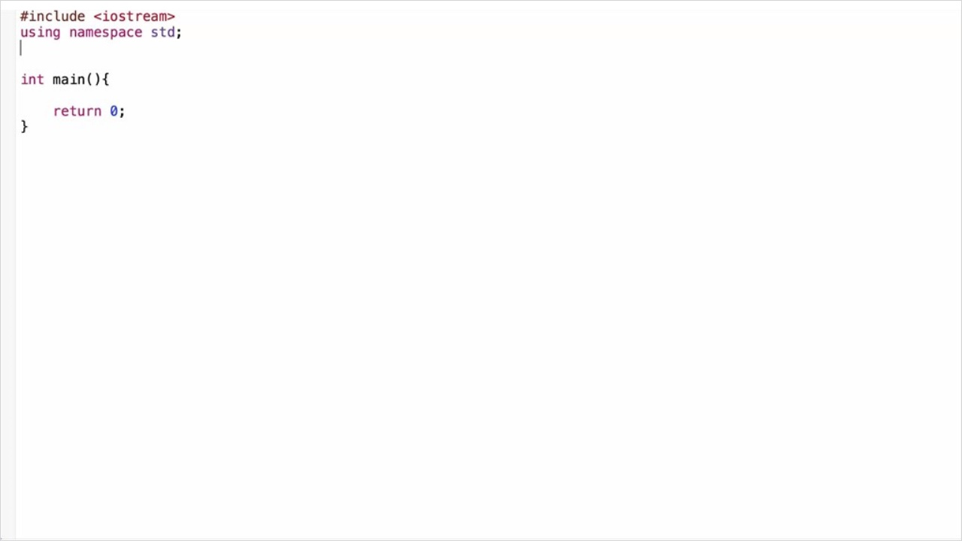

3.3 Above Average Cont'd
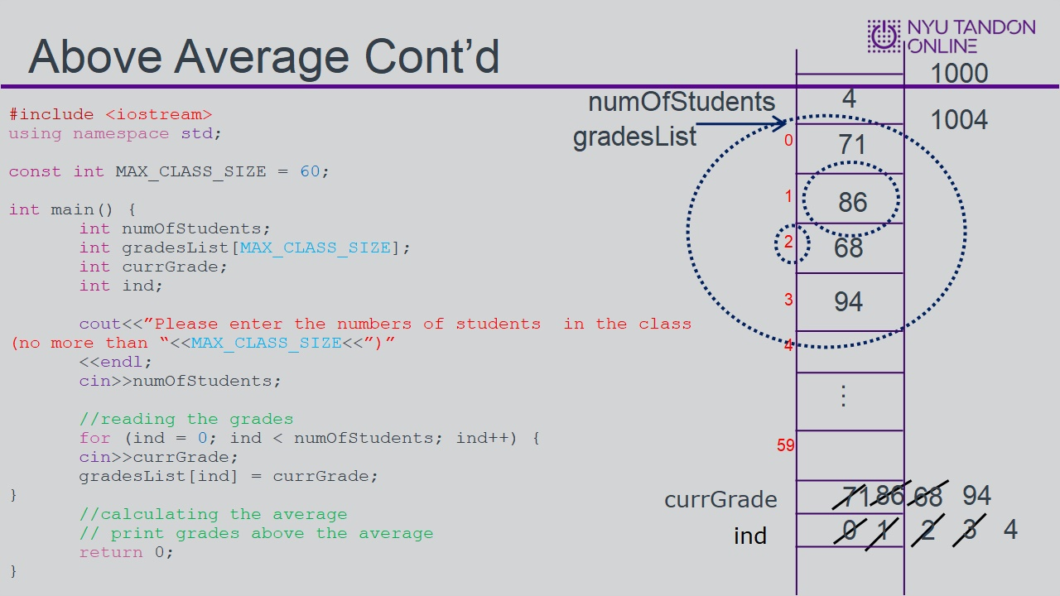

3.4 Above Average Cont'd
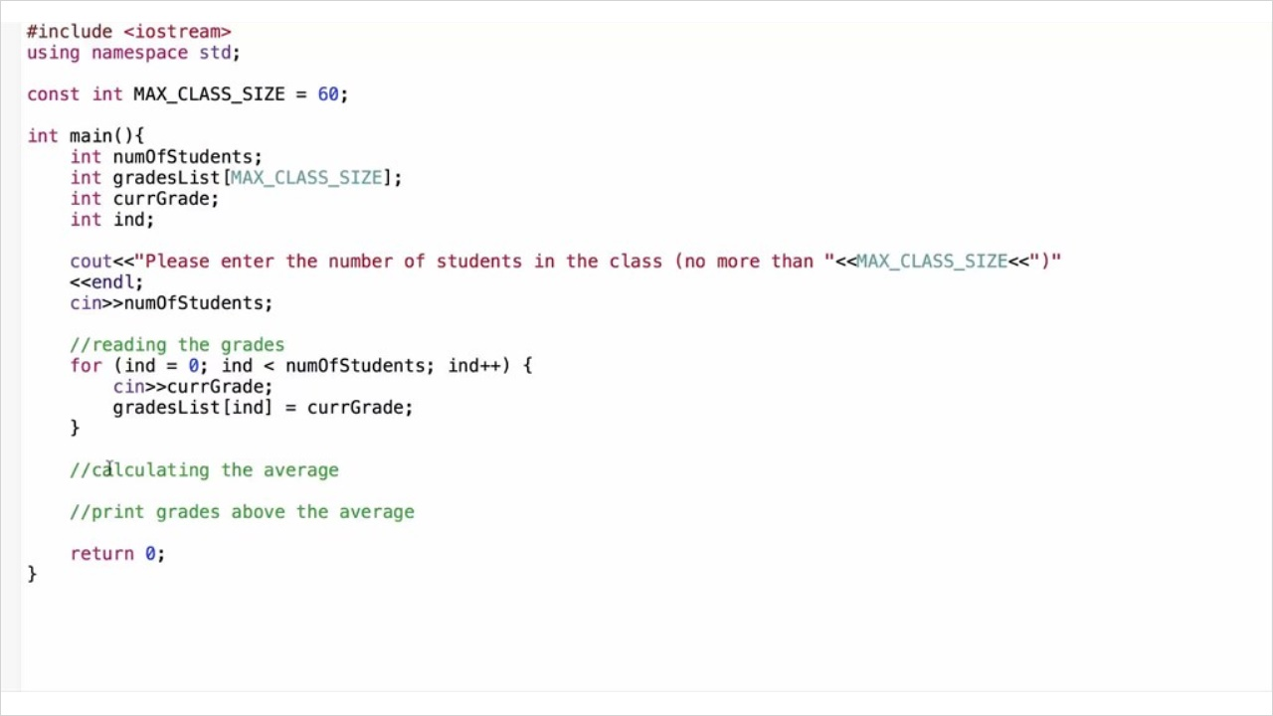

3.5 Above Average Cont'd
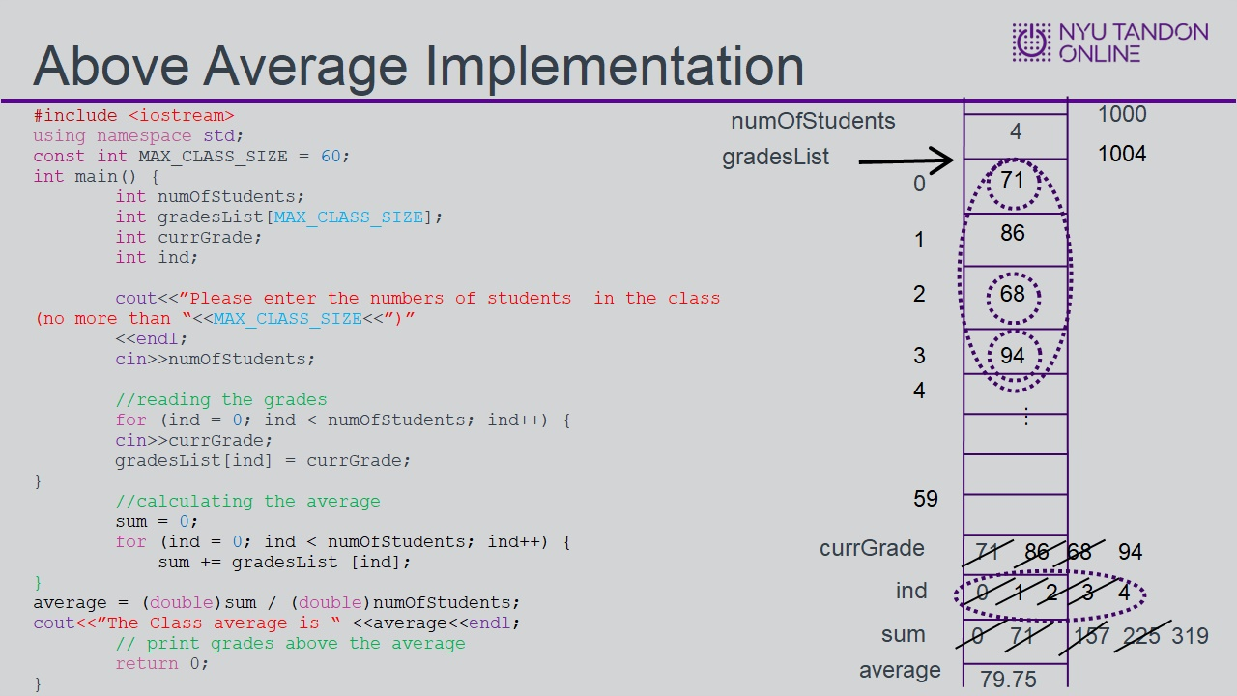

3.6 Above Average Cont'd
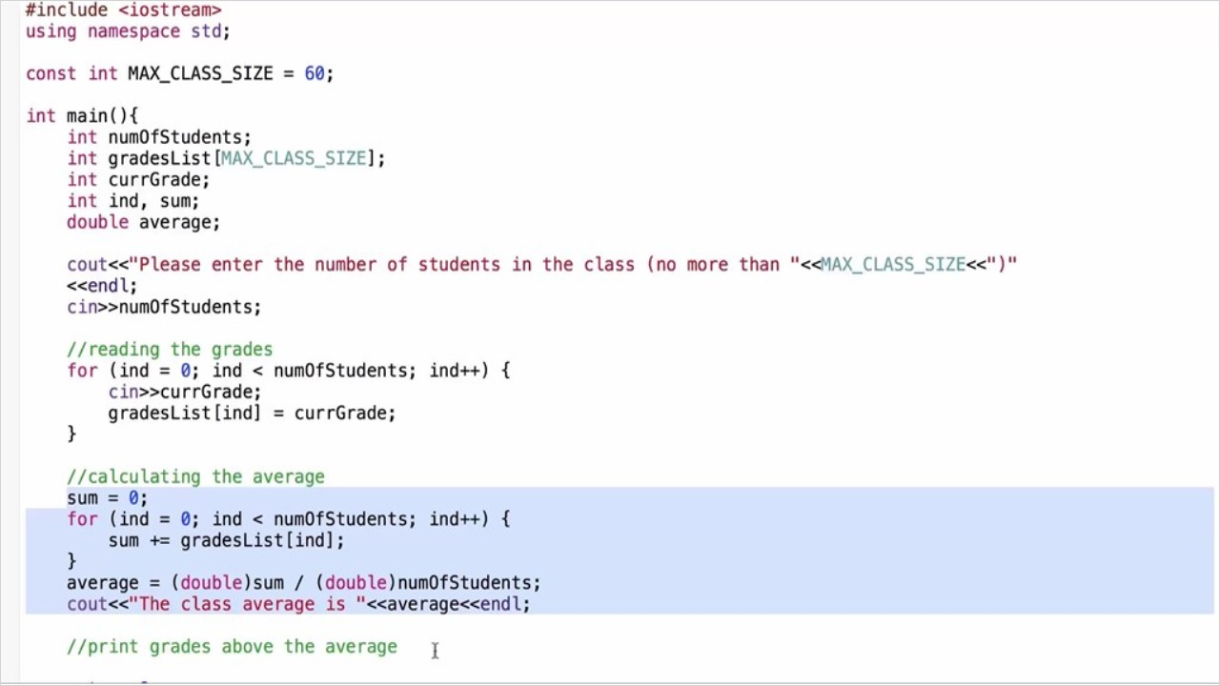
Notes:

4. Additional Syntactic Notes for Static Arrays

4.1 Syntactic Notes
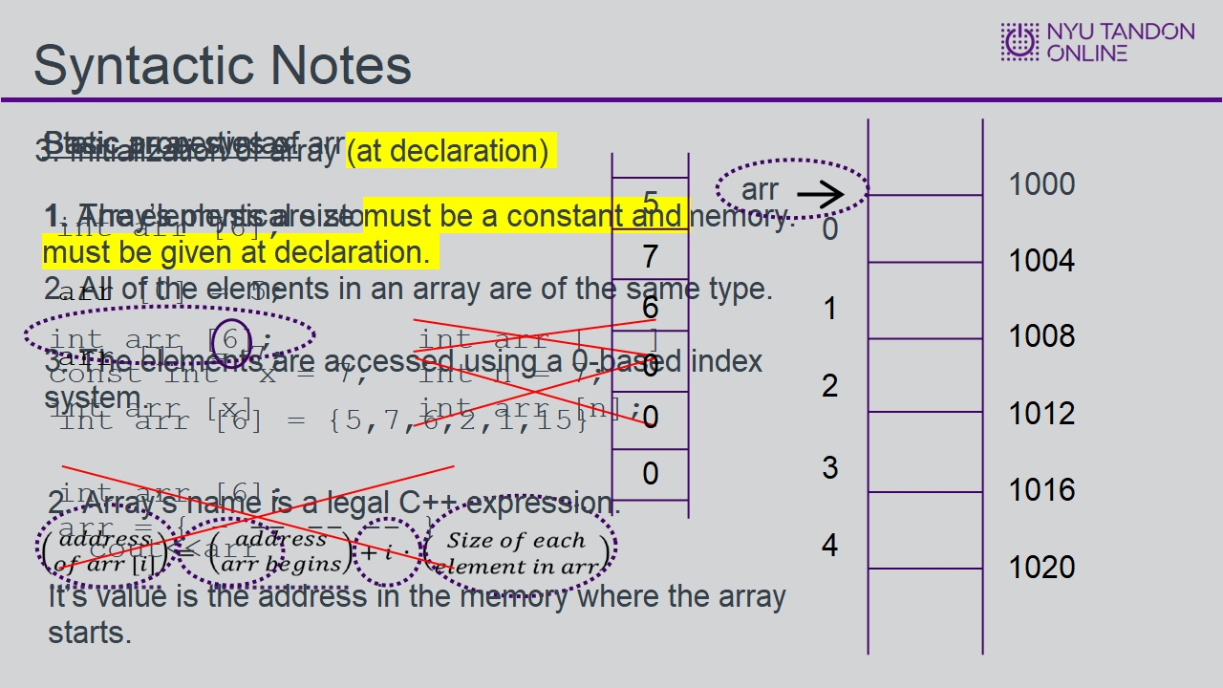

4.2 Knowledge Check
(Multiple Choice, 10 points, unlimited attempts permitted)
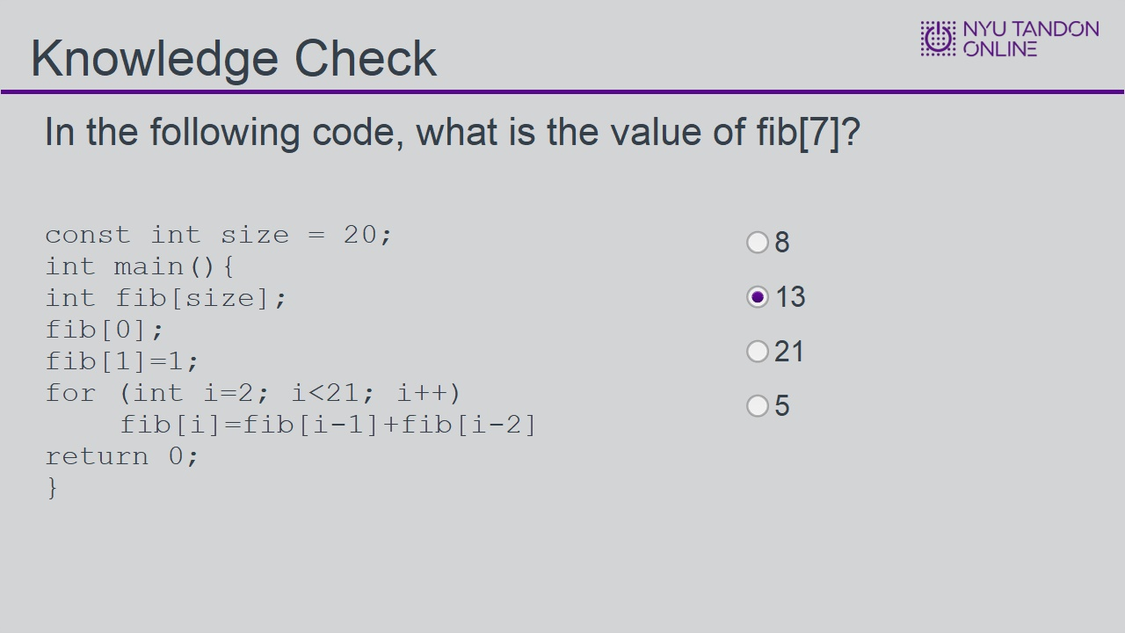
Correct | Choice | Feedback
 | 8 | Incorrect, this is the value of fib[6]
X | 13 | Correct!
 | 21 | Incorrect, this is the value of fib[8]
 | 5 | Incorrect, this is the value of fib[5]

8 (Slide Layer)
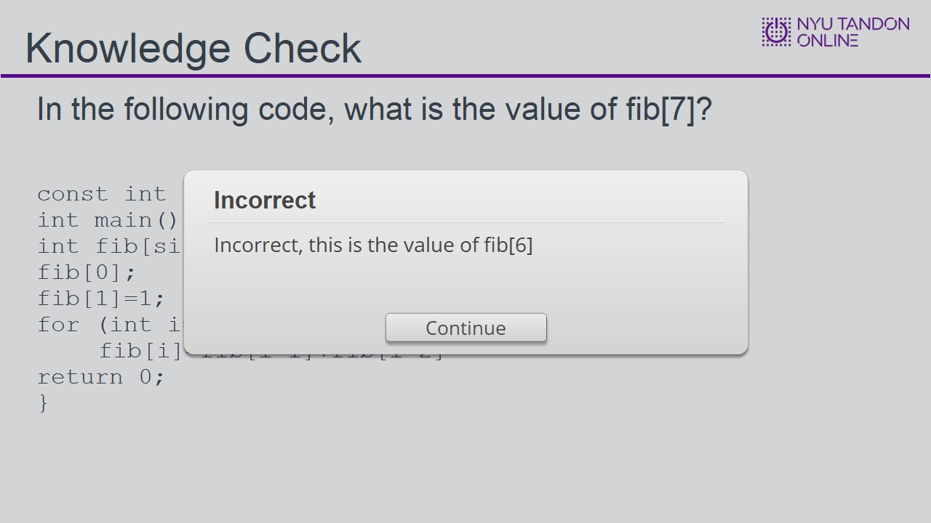

13 (Slide Layer)
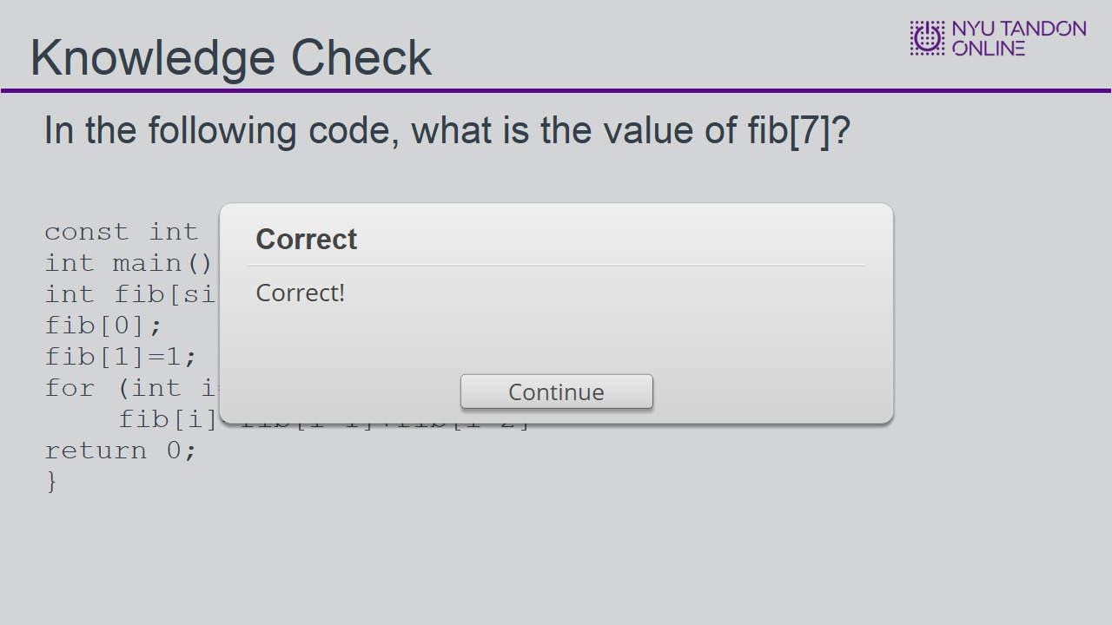

21 (Slide Layer)
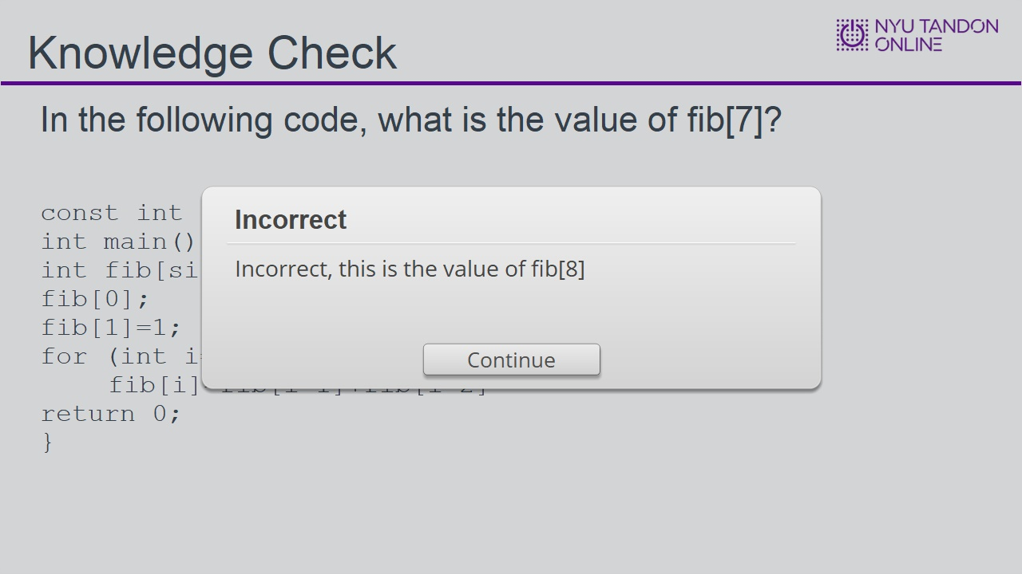

5 (Slide Layer)
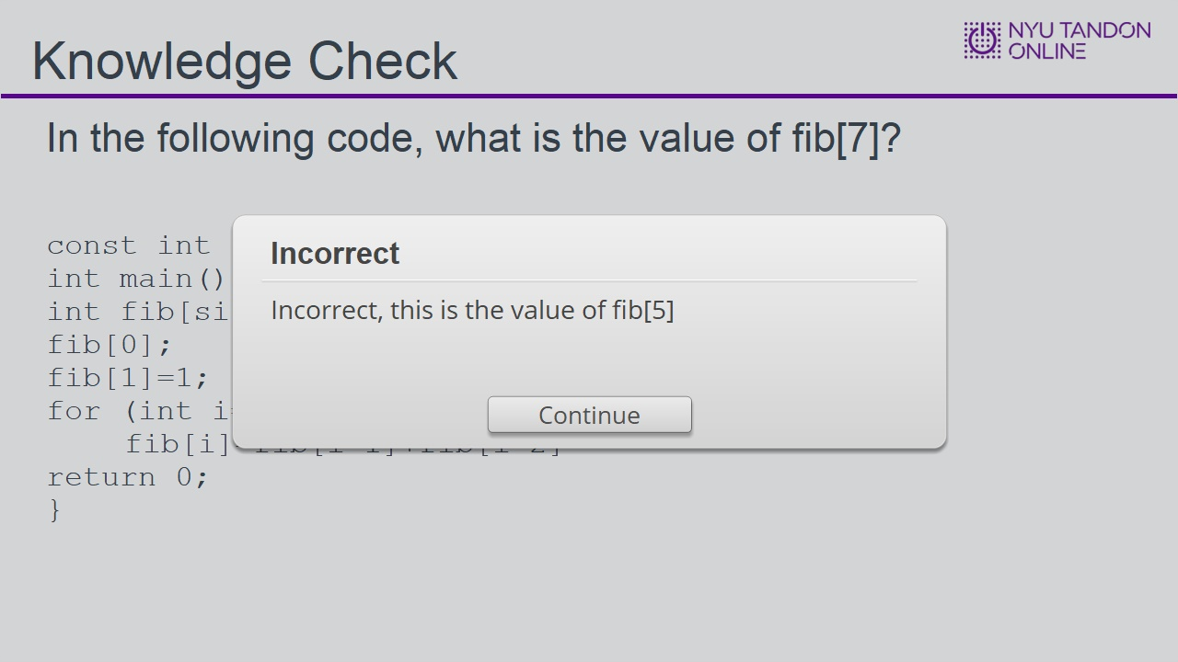

4.3 End of Module


